OPERATIONS MANUAL

HVCEB SERIES

E-BEAM

POWER SUPPLY

4,000 to 6,000 Watt

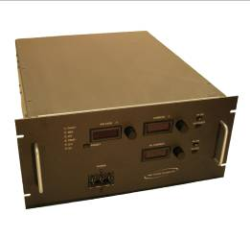
This Manual must be read completely in order to maximize safety and the life of the power supply.

If any aspect of this Manual is not clear to the user please call
High Voltage Concepts LLC.
Doc. 080502

Table of Contents

- Safety First

- Grounding the power supply

- Connecting the High Voltage Output to the Load

- Cooling & Ventilation Requirements

- Connecting the Power Line Input

- Operating the Power Supply

- Warranty & Returns Information

- Remote Interface

- Specifications

Safety First

This Power Supply can produce dangerous voltages therefore care must be observed at all times when in use.

Due to energy storage, use a Grounding Stick to discharge all High Voltage points completely.

Always disconnect and remove line power before work on, connecting or disconnecting anything.

Use power lockouts or disconnect the power cord completely so someone else doesn’t expose you to dangerous voltages by mistake while you are working on your system.

Be sure of your ground connections.
Be sure of your high voltage connections.
Be sure of your power inputs.

Connections should be done in the following sequence.

- Power Supply location: Is the power supply located in a closed rack or similar mounting away from people that may pass your area?

Is there sufficient air flow for the power supply?

- Ground connection: Connect to building ground using the main ground stud (10-32) in the rear of the chassis. Follow this connection by connecting to load ground next.

- High Voltage Connection: Connect the Two High Voltage cables to the tube filament with hardware provided. Make sure all connections are mechanically sound and sufficient space is present around the connection. The High Voltage Potential is connected to the Filament Wires.

- Input Power Connection: This must be the last connection made and the first removed when working on your system for maximum safety. Do not depend on any electronics to protect you. Removing the line power is the only way to be safe.

Grounding the Power Supply

- Be sure of all ground connections in the system.

- Since the power supply is in a metal enclosure it is imperative that this connection be made first.

- Use good heavy crimped lugs with #16 or larger green or green/ yellow striped wire as a minimum.

- Be sure all connections are mechanically and electrically sound.

- The Chassis ground insures that all voltages contained inside the power supply stay at zero potential to the outside of the chassis.

- There should be one ground to the building from the ground stud.

- There should be another ground to the load low end from the ground stud.

- Never disconnect a ground wire while line power is present.

- Always remove line power before working on your system.

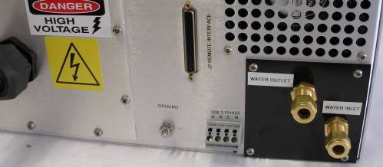
Ground Stud Must Be Connected for Safe Operation.
This is a High Voltage return current path. This must go to The Vacuum Chamber. See next page.

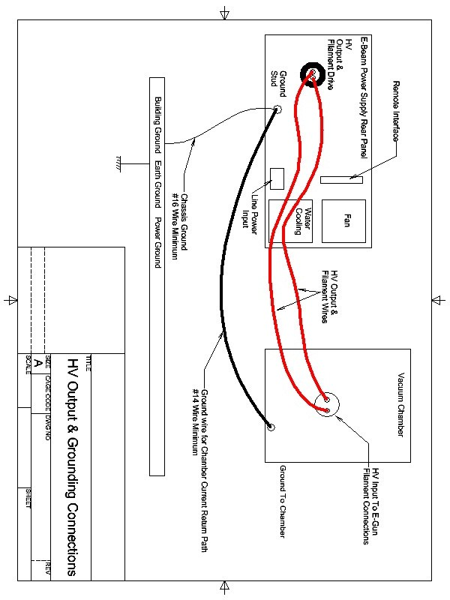

Connecting High Voltage

- Be sure line power is disconnected from the power supply.

- Be sure there is no way someone can turn on the power supply by disconnecting the line physically or use a lockout.

- Do not work alone a buddy system is best.

- Always connect the high voltage cable to the load first then plug the high voltage cable into the power supply if so equipped.

- Double check your connections.

- Does your cable require special installation instructions such as the application of dielectric grease?
- Does your cable require a certain pressure to be maintained?

- Check with the cable instructions if equipped.

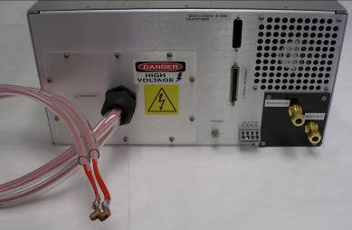
These are the High Voltage Connections for the Filament. The Filament wires are connected to the Power Supply Output Potential Internally.

Cooling & Ventilation Requirements

- This power supply is very efficient at converting power but heat is still produced and must be managed.

- Be sure the power supply has access to fresh air and is not enclosed in a non-ventilated cabinet. The Power Supply is thermally protected but this will cause it to shut down when trapped air is heated. This unit will remain faulted off for over temperature until it returns to proper operating temperature.
- Water Cooled units still require adequate ventilation for component cooling.

- Your power supply intakes air from both sides of the chassis and expels the air out of the rear via mechanical fan.

- A Water inlet and outlet is in the rear of the power supply.

- Water Temperature: 40 C Maximum @ 1 Gallon / Minute

- Ambient temperatures must be kept under 45º C for best operation and longer life.

- Do not block any one side as this can lead to thermal shut down as well.

- Do not block fan exit as this will also cause an overheating condition.

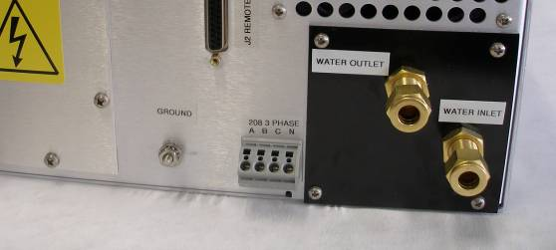

Connecting the Power Line Input

- This is the last connection that should be made when all others have been completed and the first to be removed when working on your system.

- Bring the Power Cord into the back of the power supply.

- Check your power supply to determine if it is 208 or 380 3 phase VAC.

- The 3 phases (A,B,C) are marked above the WAGO connector starting from the right. It is not necessary to provide exact phasing. The neutral must always be connected although it may not be used on some units.

- Current requirements are 25 Amps per phase for 208 and 15 Amps for 380 VAC.

- You are ready to safely turn the power supply on after reviewing Power Supply Function in the next section.

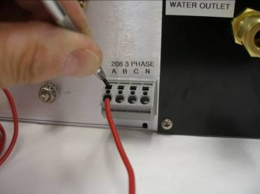
Pry Small Screw Driver toward the chassis while inserting wire into round hole. This action opens the Jaw in the round hole.

Observe this action before inserting wire.

Operating the Power Supply
Now that all the proper external connections are made it is time to review the Front Panel and Power Supplies functions.

Circuit Breaker: Switching the circuit breaker ON applies power to the unit.
The digital meters will light and you will hear the fan turn on. Shutting the circuit breaker off will also terminal high voltage and all power supply function.

There are six LED’s stacked on the left side of the power supply. Five of them are fault related. The internal fault circuit has a first fault latch to help determine what actually shut down the power supply to aid in load trouble shooting.

Polarity LED: If the power supply is a negative polarity you will see an LED light next to the “NEG”. Positive polarity units do not light the LED.

Fault LED: This LED will light with every fault, External Interlock, Over Temperature, Over Voltage, Over Current (Arcing). All High Voltage operation will be terminated upon any triggered fault. To clear a fault, depress the Off / Reset Button on the front panel or use remote Off/ Reset on the rear panel. ( See Remote Operation).

Interlock LED: This LED will light when the remote interlock pin J2-25 is opened from ground pin J2-13 terminating High Voltage operation. See remote interface.

Temperature LED: This LED will light when the internal IGBT heat sink temperature exceeds 51º C or 325º K. The unit will not clear this fault until the heat sink temperature falls below the trip point. All High Voltage function will terminate and a reset can be applied after temperature reduction. See Cooling & ventilation and remote function to read temperature.
Over Voltage LED: This LED will light and initiate a fault when the maximum high voltage output is exceeded by 105%. Under normal conditions the voltage regulator prevents this condition. The user has control over this setting from the remote control interface connector. The setting can be lowered from the 105% internal preset to any value lower than 105%. See remote interface.

Over Current LED: This LED will light and initiate a fault when the maximum current output is exceeded by 105% of full current rating. This usually happens during an output arc event. Under normal conditions the current regulator prevents this condition. The user has control over this over current setting from the remote control interface connector. The setting can be lowered from the 105% internal preset to any value lower than 105%. See remote interface.

Voltage & Current Meters: The front panel digital meters are 1% accurate and the red segments are highly visible unlike some LCD types. The Meters read the actual output voltage and current.

Preset Button: Depressing this button allows the user to view the preset voltage and current levels set by the front panel potentiometers or the remote interface set points when under remote control. The preset level can be viewed at any time even while High Voltage is On as well as local or remote mode and is 5% accurate.

Voltage LED: This LED located over the voltmeter, will light when the power supply is regulating output voltage. When High Voltage is off this LED is not lit.

Current LED: This LED located over the current meter, will light when the power supply is regulating output current except in E-Beam power supplies that have independent Voltage and current regulators due to emission current regulation.

HV ON button with LED: When this button is depressed the high voltage output will be enabled as long as the Filament is ON. The Red LED will light when HV ON condition is present. This LED will go off when Off / Reset is depressed or a fault has occurred. The HV ON button will not operate in remote mode but the LED will light.

HV On Safety Relay: When HV On is applied a relay will close providing +24 Volts to pins on the remote interface connector. This can be used to drive a relay to turn on a HV On safety lamp or another device. See remote interface.

Off / Reset: This button turns off the High Voltage when depressed as well as reset any fault that has occurred. Over temperature may require a cooling period before a reset can be accepted. This Off / Reset button will operate in local and remote mode.

Front Panel Potentiometers: These pots control the voltage and current output of the power supply. They can be adjusted to a preset level before turn on or be adjusted up or down while the power supply is operating. The power supply must have some reference on the current regulator when in voltage regulation mode. If the current reference is set to zero and HV ON is applied, no output may result. Filament standby will not operate with zero current reference. The reverse is also true. In remote mode these front panel potentiometers are disabled. See remote control.
Filament Current Meter: Filament Meter is located below the HV output Current Meter. Front Panel Filament Potentiometer if so equipped can be overridden from the remote interface. If Equipped with Rear Panel Potentiometer that sets the standby filament current it cannot be overridden from the remote interface.
Filament Control ON/Off: This button controls the filament circuit. When the button is pressed the LED in the button will light and the Filament Meter will read standby current. When HV ON is applied the filament will go to emission current regulation mode automatically. A High Voltage fault or HV Off command will transfer the filament from emission current regulation back to standby until the fault is cleared and HV On is reentered.
Coolant Pump Relay: When Filament On is applied a relay will close providing +24 Volts to pins on the remote interface to power a relay to turn on a coolant pump for your tube & power supply. See Remote Interface.
Filament Preset level: The front panel potentiometer may be adjusted to vary Standby Filament {pre-heat}. The remote filament reference will override this setting.
Remote Filament Reference: Using the remote filament reference can be used in any mode and will over ride front panel settings when used. (Rear panel adjustment pots cannot be overridden).
Remote Filament Monitor: This is available at all times via the remote interface analog output in the rear of the chassis. See remote interface.
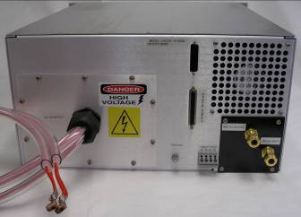
J2 Remote 37 Pin Sub-D

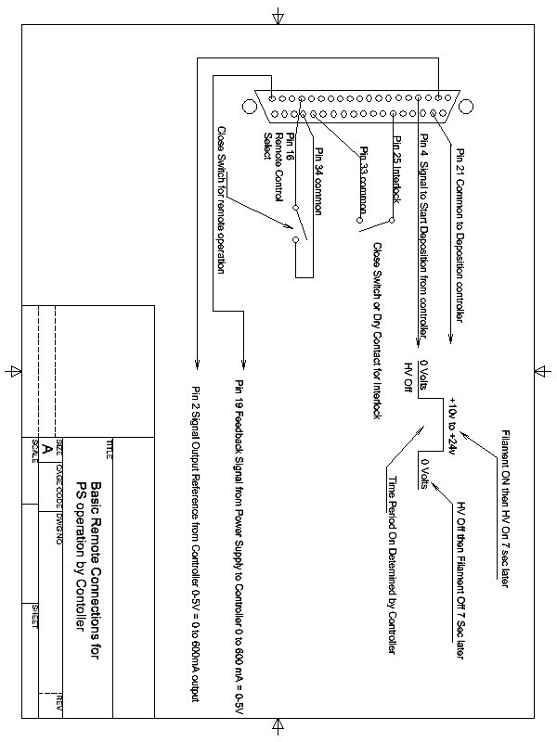

E-Beam Front Panel Function Description
Digital Current Meter & Local Current Control for full manual use. Remote mode allows any type of Rate Controller to be used
Preset Button allows view of reference voltage & current in any mode HV On or off, Local or Remote
Digital Voltage Meter
& Voltage Control

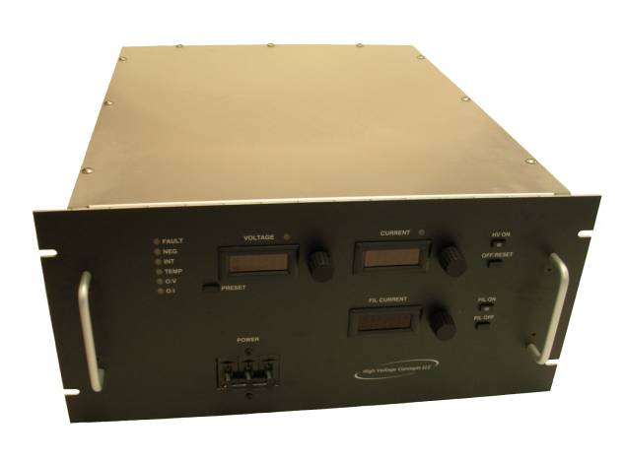
Filament Current Meter with Adjustable Preheat current, hands off automatically to emission current regulation during HV On & returns to Preheat upon HV off. If your unit has no adjustment knob it has a rear panel adjustment pot that is set at the factory to 22 amps. This prevents customer tapering.
Status Indicators for: Interlock, Temperature, Over Voltage, Over Current with first fault circuitry.
E-Beam Units are equipped with a fast Arc rollback circuit and will ride thru all arcing with-out shut down.
Circuit Breaker for Power On
HV On off Command local mode.
HV On off is Commanded by Rate Controller in remote mode.

Filament On off Command local mode.
Filament On off is Commanded by internal sequence circuitry in remote mode.

6kWatt E-Beam Rear Panel.
Remote interface connector 37 pin Sub-D. *(See Remote Analog Interface for Details)
Air Circulator fan for low dissipation components
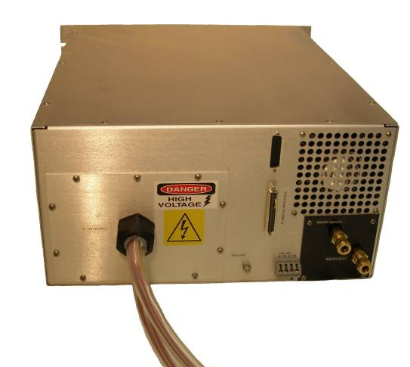
Power Input Connector 208 VAC or 380 VAC 3 phase & N
Ground Connection to Vacuum Chamber
High Voltage Output cables with Filament for easy e-gun connection.

Water Cooled Main Drive Circuit Thermally Protected providing the ultimate in reliability
Rate: 1 gallon per minute, 400 joules/sec

Remote Analog Customer Interface (E-Beam Pin-Out)
37 Pin Sub-D Connector
Remote FEMALE SUB-D connector is on the back panel a Male Sub-D mate is provided.
- Voltage Reference: Voltage Control for E-Beam remains with front panel control at all times.
- Current Reference: 0-5 Volts Input =0 to Full Output Current. This Reference must be connected to 5 Volts when using this supply in Voltage only mode, otherwise the auto-crossover control will believe you are requesting near zero current and no output will result. This only operates in remote mode.
- N.C. This pin has no connection.
- Remote HV On-Off/Reset: Apply and maintain voltage in range (+8.5 volts minimum to +24 volts maximum) to turn on HV. This sequence will occur after application of stated voltage; Filament will energize in standby mode 7 seconds later HV will turn on. Upon removal of the stated voltage HV will turn off then 7 seconds later the filament will turn off.

- NC. This pin has no connection.
- Remote kV Monitor: 0-5.0 Volts = 0 to Full Output Voltage. Output Impedance of this device is 1k Ohms. This Function is available in any mode.
- Remote Over Voltage Fault Set-point Reference: 0 to 5.0 Volts = 0 to Full Output Voltage over rides the internal Over Voltage setting which is fixed at 105% of the full output voltage. This function is available in any mode.
- Remote Over Current Fault Set-point Reference: 0 to 5.0 Volts = 0 to Full Output Current over rides the internal Over Current setting which is fixed at 105% of the full output current. This function is available in any mode.
- +5 volts.
- Filament Monitor. 0-5 volts = 0- Full Current Amps this signal is present in all modes.
- +15 Volts 20mA Max
- -15 Volts 20mA Max
- Common.
- HV On Signal. When HV On is commanded this pin goes Low. Its output impedance is 2k ohm, and the High position is +5 Volts. This signal is always present in Local and Remote control.
- Common.
- Local/ Remote Command: Pulling this pin LOW and holding will remove control from the front panel. The Front Panel Potentiometer References will be over ridden as well as the HV On Command. Meters will function normally and the Preset button will read the remote program reference inputs instead of the Front Panel Potentiometers. All LED function remains.
- Temperature: This pin reads the temperature of the IGBT in the power driver. The measurement is in Kelvin/100. Room temperature will read 2.93V or 293º Kelvin. This function is available in any mode.
- NC. This pin has no connection
- Remote Current Monitor: 0-5Volts = 0 to Full Output Current. Output Impedance of this device is 1k Ohms. This function is available in any mode.
- Fault Signal. When Fault is triggered this pin goes Low. Its output impedance is 2k ohm, and the High position is +5 Volts. This signal is always present in Local and Remote control. To clear fault cycle HV Off/Reset see pin 4.
- Common.
- +5 volts. 100mA Max.
- Remote Filament Reference Input. 0 to 5 volts = 0 to Full Current. This signal must be 500 ohm or lower output impedance to override the front panel, a 1k ohm potentiometer will work. This function can’t be used with rear panel filament adjustment pots.
- Reference Voltage +10 Volts: 5mA Max Current Draw.
- External Interlock: This pin must be held LOW in order to operate power supply. A HIGH or an OPEN on this pin will trip the unit off via an Interlock FAULT and block the application of HV ON. This pin must be held LOW before the OFF/ RESET command can be used to clear the fault. This function is always available.
- Remote High Voltage lamp On. {+} Provides +24 volts source for a lamp when high voltage is enabled.
- Remote High Voltage lamp Return. {-}Return for +24 volts lamp.
- Pump Voltage Return. {-}Return for +24 volts for coolant pump relay.
- Pump Voltage +24 volts: {+} Provides +24 volts source for tube coolant pump relay. Other voltages are available.
- Filament On Remote: Controlled by HV On- Off/Reset see pin 4.
- Filament Off Remote: Controlled by HV On- Off/Reset see pin 4.
- Filament On Signal: This pin is normally high (+5 Volts) with Filament OFF and Goes Low when Filament is ON.
- Common:
- Common:
- Common:
- & 37. Spare:

STANDARD TERMS AND CONDITIONS

The following terms and conditions apply to any referenced quotation or order.

Acceptance:
If a Buyer’s order contains any term, condition and/or provision which are in any way inconsistent with or in addition to High Voltage Concepts, LLC Terms and Conditions, they shall not be applicable to or binding upon High Voltage Concepts, LLC. If the Buyer objects to any term contained herein, such objection must be in writing and received by High Voltage Concepts, LLC prior to the commencement of the order. Any acceptance of goods by Buyer from High Voltage Concepts, LLC shall constitute acceptance of the terms and conditions stated herein.

Terms:
- All orders are subject to final acceptance by our Credit Department.
- All shipments are F.O.B. origin (Brewster, New York, USA).
- High Voltage Concepts, LLC reserves the right to make shipments in part or in whole. Invoices for such shipments shall be accepted and paid as rendered. Our terms are Net 30 Days, unless otherwise specified.

Product Specifications:
Specifications listed in current catalogs or specifications sheets supersede specifications in all previous catalogs or specification sheets and constitute performance for warranty. High Voltage Concepts, LLC reserves the right to make changes in design, specification, and construction at anytime without incurring any obligation to make any changes on products previously purchased. Customer specifications assigned to High Voltage Concepts, LLC part number must be preceded by written specification submitted for review and approval. Under all circumstances, the standard product specifications will prevail. Any special requirements adding to or deviating from the standard specification will require High Voltage Concepts, LLC to assign a specific and separate part number to the custom product and price it accordingly.

Packaging & Shipping:
All products are packaged for safe shipment in accordance with good commercial practices. All packaging will confirm to requirements of carrier’s tariffs. If there are special packaging and/or shipping instructions, they must be sent in writing and accepted by High Voltage Concepts, LLC. In the absence of such instruction, High Voltage Concepts, LLC will ship by an appropriate method.

Shipping Damage:
It is the responsibility of the customer to advise the carrier of any damage incurred in transit.

Contingencies:
Shipping dates are approximate and are based upon prompt receipt of all necessary documents and information. High Voltage Concepts, LLC will use its best effort to ship as specified herein but shall not be liable for any delay in delivery or for non-delivery, in whole or in part, caused by the occurrence of any contingency beyond the control of High Voltage Concepts, LLC or its Suppliers; including but not limited to war, fire, floods, accidents, riots, terrorist acts, government interference or embargos, labor disputes or shortages of, fuel or raw material.

Warranty:
High Voltage Concepts, LLC warrants that the product sold is free from defects in material and workmanship. The responsibility or obligation of High Voltage Concepts, LLC to the original purchaser is limited to servicing the product and/or replacing defective parts after a Return Authorization has been received by the customer to return the product, prepaid, to High Voltage Concepts, LLC. Exception is taken, where applicable to vacuum tubes of any kind limited by service life or other warranty by the manufacturer, and/or parts installed supplied by a customer. This warranty is valid providing that the product has not been abused or altered mechanically or electrically, and has been operated within all its specifications. The period for warranty for all products is thirteen (13) months from date of shipment of the product to the original purchaser. This warranty is void if the serial number removed, altered, or if is determined, after examination by High Voltage Concepts, LLC, that defects were caused by improper operating conditions or service was attempted by personnel not authorized by High Voltage Concepts, LLC. This warranty is in lieu of all other warranties, expressed or implied, including but not limited to any implied warranty of merchantability or fitness for any particular purpose or use. High Voltage Concepts, LLC is not liable for consequential damages.

Repairs:
Products returned for repair must have a Return Authorization Number obtained by calling High Voltage Concepts, LLC. This number is essential for warranty enforcement, aids in the quick repair and tracking of the return. Any product returned without a Return Authorization Number or shipped freight collect will be refused. An evaluation charge will be applied to all products returned for repair, unless the unit is found to be defective and in warranty. All products returned must be properly packaged and shipped prepaid, and include documentation explaining the trouble or malfunction experienced. The product will be evaluated, repaired or replaced at our sole discretion and returned prepaid if warranty claims are substantiated. Products returned out of warranty that are deemed beyond economic repair will be scraped at High Voltage Concepts, LLC or returned to the customer at the customers’ expense, evaluation charges apply.

Debits:
Debit memos will not be accepted.

Cancellation:
In the event that a Buyer cancels an order, in whole or in part, the request must be submitted in writing to High Voltage Concepts, LLC. Cancellation charges shall include a price adjustment based upon the quantity of product delivered, and all costs direct and indirect, incurred and committed for this order with reasonable allowances for prorated expenses.

Continued…..

Use of Confidential & Proprietary Information:
High Voltage Concepts, LLC at its sole discretion, will be disclosing such confidential and proprietary information as it deems appropriate, including, but not limited to, know-how, methods, processes, plans, drawings, designs and other product information of High Voltage Concepts, LLC. As a condition to the furnishings of such information, you hereby agree to hold such proprietary information in the strictest of confidence and are not to reveal, divulge or make known to any person, nor use such proprietary information, either on your own behalf or on the behalf of any third party, for any purpose whatsoever, during or after any relationship with High Voltage Concepts, LLC, except as otherwise agreed in writing by High Voltage Concepts, LLC. You will take all reasonable steps, including, but not limited to, those steps taken to protect information, data or other tangible or intangible property of your own that you regard as proprietary and confidential, to ensure that, other than as agreed to herein, such proprietary information is not disclosed or duplicated in whole or in part for the use of others. Title to all proprietary information disclosed or made available to you and all rights therein, shall remain vested in High Voltage Concepts, LLC and such proprietary information is understood to be a trade secret of High Voltage Concepts, LLC. You hereby expressly acknowledge that title to such proprietary information is vested at High Voltage Concepts, LLC not withstanding the fact that you may have made partial payments in connection with such proprietary information. Upon demand by High Voltage Concepts, LLC or the termination of any relationship between you and High Voltage Concepts, LLC, you will surrender to High Voltage Concepts, LLC any and all material, including, reports, lists, manuals, processes, methods, proposals and the like including copies and notes of the contents or parts thereof that you have in your possession which is proprietary information.

Doc. Date: 060425

4,000 – 6,000 Watt E-Beam Series
High Voltage Power You Can Depend on!

- HV Output & Filament all in one design. Rugged and Design to last!
- Digital Front Panel Meters and Controls for Voltage, Current, and Filament.
- +24V to Drive Tube Coolant Pump Relay with application of Filament ON.
- +24V to Drive Safety Light Relay with application of HV ON.
- Remote Monitoring and Programming Standard HVC Pin-out. Rugged and Design to last
- Standard 8 ¾ inch Rack Mount 21 inches Deep. HV Connectors and hardware to terminate supplied.
- Weight: 42 Lbs
- Standard Ripple 0.1% rms
- Automatic Emission Current Regulation
- Self Protection from Arc, Over Voltage, Over Current , & Temperature.
- 3-way Filament Regulator Control (Standby Current, Maximum Current, Emission-Current).
- Filament Power up to 800 watts (Consult Factory with your application).
- OEM and Custom Designs. Other Voltages and Power Levels available upon request.

Model | Max Power | Voltage | Current | Std.  Input VAC | Alt.  Input VAC
HVCEB-5-800 | 4000 watts | 5kV | 800mA | 208 3 phase | 380 3 phase
HVCEB-10-400 | 4000 watts | 10kV | 400mA | 208 3 phase | 380 3 phase
HVCEB-5-1000 | 5000 watts | 5kV | 1,000mA | 208 3 phase | 380 3 phase
HVCEB-10-500 | 5000 watts | 10kV | 500mA | 208 3 phase | 380 3 phase
HVCEB-5-1200 | 6000 watts | 5kV | 1200mA | 208 3 phase | 380 3 phase
HVCEB-10-600 | 6000 watts | 10kV | 600mA | 208 3 phase | 380 3 phase
Line Regulation: +/- 0.001% of Full Voltage
Load Regulation: +/- 0.005% of Full Voltage
Ripple: Standard (0.1% rms)
Operating Ambient Temperature: -15º C to 45º C
Water Temperature: 40 C Max @ 1 Gallon / Min. Storage: -40º C to 85º C
Stability: +/- 0.01% per hour
Weight: 42 Lbs.
Note: Specifications are subject to change without notice.

